Differential Wine Bottle Opener

EML3262 Fall 2025

Avery Tidlund
Jacob Rowe
John Pollitt
Noah Newman

Table of Contents

Introduction & Ideas 1
Development 1
Detailed Design 2
Significance 3
Implement 3

Introduction & Ideas
The design process began with a single idea: how to make a wine bottle opener easier to use. Anyone who has used one before knows they can be strenuous and difficult to wield. Additionally, even if one does possess the strength necessary to employ one, it takes incredible skill as well, unless it is preferred for the wine to be mixed with cork or glass. So how to simplify this process? The first idea was to merely design a longer lever arm, allowing for more mechanical advantage. Although this could work, it may make the device more unwieldy and storage to be irritating. The second idea was to utilize a handle that could be turned to pierce the corkscrew into the cork. This has been made before, and presents its own difficulties, like needing the screw to be perfectly lined up in the cork. Lastly, it was proposed that we make a device that can screw into the cork and lift it from the neck of the bottle in a single motion with the lever. This presented a series of challenges: how would the direction reverse without physically reversing the direction of the handle, how to stop the corkscrew from spinning after it reaches proper depth, and keeping everything simple enough to be used by a layman. It was decided that these challenges would be tackled, and our group set off to solve them.

The plan was simple: create models using 3D software or sketches. Each member would have their own design that satisfies the criteria. One member’s design would be chosen and then refined. Once refined, the 3D printing phase would begin. The corkscrew would not be printed, a metal one is necessary, and our group did not possess the tools or skill to create one from scratch. Cutting one off an existing wine bottle opener would satisfy our needs. Connections for the arms, levers, and the shell of the device would be fitted with steel bearings. A few dozen were purchased cheaply. But the bulk of the device would be 3D printed, and it was quickly discovered that this phase would require much more polish even after the initial refinement. 3D printers aren’t perfect, and neither are cheap steel ball bearings. Tolerance levels must also be considered. Test pins and bearing holes were assumed to be needed. Once printed, the device was to be assembled.

Of all the designs proposed by the group, we chose the most challenging one. A normal wine bottle opener consists of a simple lever that moves the corkscrew down with the down motion and up with the up motion. This would suffice to complete the task, but Jake came up with a much more interesting idea in which one movement down of the lever arm would spin the cork down and back up. One motion could be translated into two directional motions and a rotational motion of the cork. This design would more than satisfy the challenge problem of simplifying the process of opening a wine bottle. From many complicated movements and positions, this would transform the process into something much simpler.

Although the design would be more complicated than the other designs, it would be a much more fun and unique project to create as we had not seen a device like this before. Our design has 1 DOF and 3 closed loops. It has symmetry at the neutral position with parallel couplers. If starting from the lever arm in the up position the corkscrew attachment would be up into the device, as the lever arm is moved down the corkscrew would slide down and spin through a rifled cylinder to engage the rotation of the corkscrew. When the lever arm returns to neutral, the mechanism would again be in the neutral position. If you continue to push the lever arm down the coupler arms would move in the opposite way that they did on the first movement and it would lift the corkscrew up again. A differential slider would be fastened to the bottom of the corkscrew attachment which will stop the spinning motion. This is required as you want the corkscrew to spin into the cork while going down and pull up straight when lifting so that it does not spin out of the cork but instead pulls the cork up and out of the bottle. This would be the most challenging part of the design. To turn the motion of one lever into a complex set of multiple motions up, down, rotating, and not rotating all with 1 DoF.

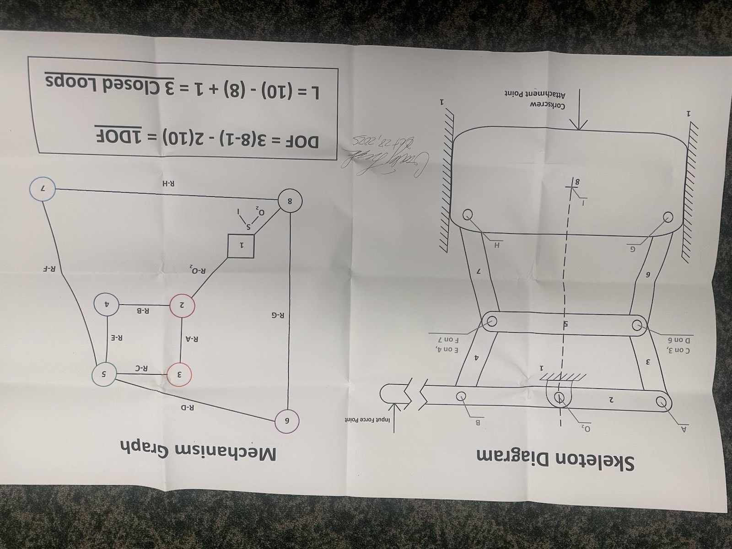

Development
The mechanism, containing ten links and thirteen lower pairs, has only one degree of freedom. The input for this freedom is a lever attached to a compliant parallel mechanism. This mechanism is attached to the corkscrew. Applying force to this lever will change the side links of the coupler to be either “high” or “low”. This relationship makes it possible for the lever to only be pulled in one direction to accomplish the desired motion of the corkscrew. A complete movement of the mechanism is characterized by pulling the input lever down, forcing the corkscrew into the cork. At a halfway point, the corkscrew will reverse directions as the input lever continues in its downward motion. The differential lever arm is activated by reaching this halfway point, and the corkscrew stops rotating as it travels vertically upward. The motion is complete when the input lever is fully lowered, removing the cork from the bottle.
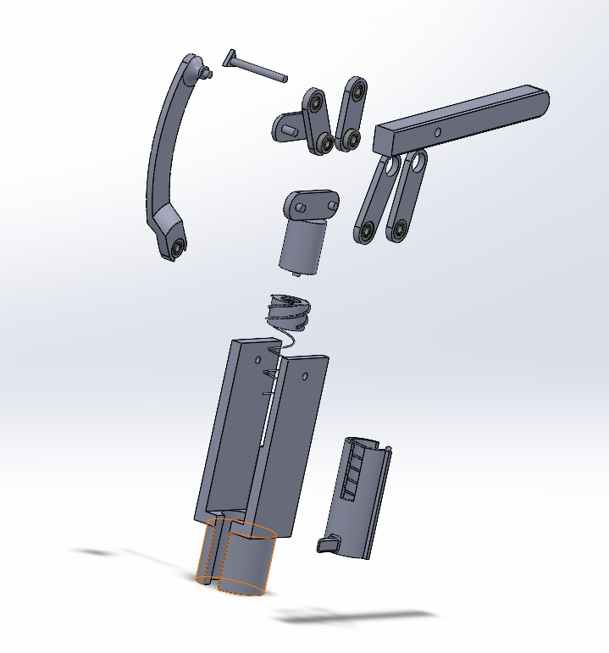
2
9
8
6
7
5
4
11
10
3
1
Figure 1: Exploded View
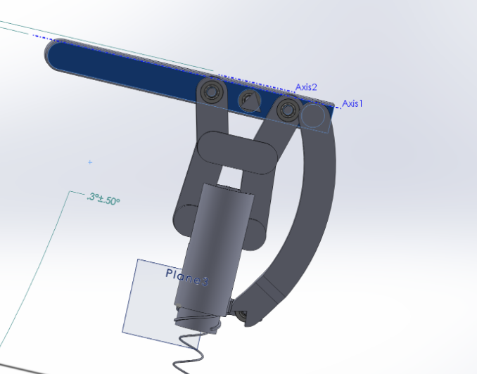
K
A
O2
B
D
C
E
F
L
G
Figure 2: Pin Locations

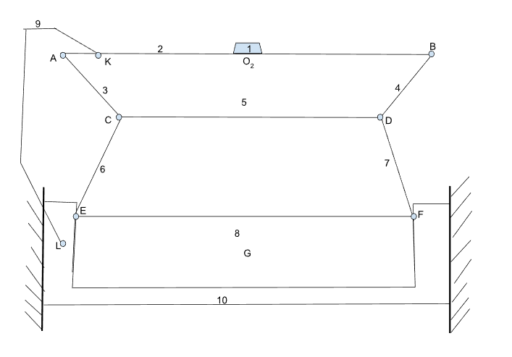
Figure 3: Skeleton Graph
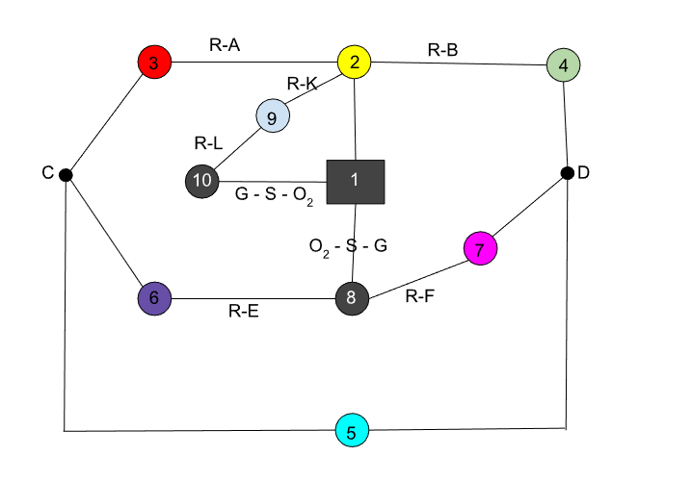
Figure 4: Colored Mechanism Graph

Figure 5: Table of Link and Pin Descriptions
Link/  Joint | Description
1 | Ground pin. Provides stabilization to other links and prevents unwanted motion
2 | The lever arm. This is the input of the mechanism.
3 | Side link arm. Connects the input link to the coupler link
4 | Side link arm. Connects the input link to the coupler link
5 | Coupler link
6 | Side link arm. Connects the coupler link to the slider
7 | Side link arm. Connects the coupler link to the slider
8 | Corkscrew slider. Screws into the cork. This is the output of the mechanism
9 | Differential link. Controls whether the corkscrew slider rotates or not.
10 | Differential rifled slider. Mechanism attached to the differential link that controls rotation
11 | Outer housing. Encases the inner mechanism and helps to act as ground.
A | Connects input link (2) and side link arm (3)
B | Connects input link (2) and side link arm (4)
C | Connects the side link (3) to coupler link (5). Also connects side link (6)
D | Connects the side link (4) to coupler link (5). Also connects side link (7)
E | Connects the side link (6) to the corkscrew slider (8)
F | Connects the side link (7) to the corkscrew slider (8)
G | Line of action of the slider that is coincident of the ground pin O₂ (1)
K | Connects the differential arm (9) to the input link (2)
L | Connects the differential arm (9) to the differential rifled slider (10)

Detailed Design
In our design a slider link 8 is moved up and down by the movement of the two closed loops above it. Through testing the parameters of multiple configurations to get the desired movement we found that having links 3 and 4 be the same length as well as links 6 and 7 be the same dimensions was necessary. This was important because the mechanism moves slider 8 up and down in one directional movement of the lever arm 2. Since the motion would be repeated, starting in the up position going down and then returning to the same up position we needed to shape of the loops to be symmetrical on both sides otherwise the end positions would be different depending on if the bar was in the upmost position or the downmost position.
Links 3 and 4 needed to be shorter. This allowed the angle of the lever arm to more quickly change the shape and position of link 5 which would pull up the second loop and slide 8 vertically. Additionally, due to the proximity of lever arm when the links 3 and 4 were longer we experienced collision of mechanism with itself. Through experimentation, the optimal movement was found with links 6 and 7 being slightly longer.
The design element constraint primarily revolved around the vertical range that slider 8 would move on. Taking the average wine cork length of 44mm and the recommendation found from wine resources available online, it was recommended that the corkscrew penetrate the cork at least ¾ of the way thru the cork. This meant that we needed a minimum penetration depth of 33mm for the average cork length. The corkscrew itself would sit above the wine bottle in the housing about 10 mm to ensure that it does not interfere or poke the user when not in use. Taking this design aspect into consideration, we came up with a final number of 43 mm of vertical range as our target. The final result ended up being a vertical range of 43.91 mm. When landing on this vertical range we were able to finalize the dimensions of our couple arms for both closed loops.
If this mechanism was to be redesigned for bottles using a larger cork the simplest way would be to change the dimensions of the pins of the couplers on the lever arm Link 2, the length of link 5 or the pin connection distances of link 8. Doing so would change the vertical range of the mechanism without changing its movement or design drastically. Allowing you to remake it with most of the same parts. The table below shows the parameter changes.

Figure 6: Optimization Table
Parameter | Parameter Change | Effect on Output Range (mm) (Vertical Movement of Link 8)
R5= 47.91 | ΔR2= +5mm (+11.65%) | 51.39 mm (+17.03%)
 | ΔR2= -5mm (+11.65%) | 36.52 mm (-16.83 %)
R8= 60 | ΔR2= +5mm (+8.33%) | 41.62 mm )-5.22%)
 | ΔR2= -5mm (-8.33%) | 44.46 mm (+1.25 %)
R2= 75 | ΔR2= +5mm (+6.67%) | 39.58 mm (-9.86%)
 | ΔR2= -5mm (-6.67%) | 51.14 mm (+16.47%)

As shown above, changing R5 gives the largest percentage increase on the vertical range. For example, a wine bottle opener designed for the largest corks of up to 55 mm, a ¾ penetration depth would be 41.25 + the 10mm design spacing leads to a necessary range of 51.25 mm. This is almost exactly the range create by changing R5 from 47.91 mm to 52.91 mm.

Significance
A certain mechanical advantage was needed to remove the cork from the bottle, but this was not the primary design objective for this project. The human hand is more than capable of piercing a wine bottle cork easily, so we need not multiple our force to accomplish the goal. In fact, most wine bottle openers do not offer any mechanical advantage as the user is expected to pull it straight out. The primary challenge statement was about creating a device that simplified multiple complex motions into one simple motion. A single pull down of a lever would create a down ward and upward motion while simultaneously triggering a controlled spin in the downstroke then stopping the spin and maintaining a straight slide for the subsequent upward motion to ensure that the corkscrew threads into the cork going down and does not unthread from the cork while being pulled up. This tricky maneuver was accomplished by a differential rifled slider attached to link 9 which was in turn attached to link 2. When the lever arm link 2 moves up and down it would move link 9 up and down as well. The difference and reason that link 9 had to be attached separately to the differential slider is because this motion had to be independent of the up and down motion of link 8 slider. Link 9 could not could up and down in the same motion but rather had to go just down or just up. This allowed us to isolate the rotational motion separately from the sliding motion of link 8 and in turn gave the desired outcome of allowing the corkscrew to rotate through half the motion instead of the entire motion.
This idea was by far the most complicated problem to solve. Many various ideas were proposed, and an entire meeting was dedicated to addressing this issue. Levers, buttons, alternative handles were suggested, magnets, pins and springs were considered, but ultimately this solution allowed to achieve the differential rotation without the use of magnets, springs, and tiny levers or pins which was essential as everything would could not 3D print we would have to buy and source and make sure that they integrated well with the print dimensions of the mechanism.

Implement
The final dimensions of the prototype were primarily chosen through the design stage in SolidWorks. With the use of SolidWorks assembly features were assembled the protype, tested its range of motion, ran test to see if any of the pieces experienced undesired collisions with other pieces and measured the vertical output motion range to ensure that we were meeting our target specs. The primary cause for reprinting had to do with the specs of the threading on the rifled slider. This simulation in the assembly of solid works did not operate as intended inside the program and therefore required printing, testing, identifying problems, redesigning in Solidworks and then reprinting again. The printing went very smoothly for some aspects and very poorly for others. The ball bearing pin joints were purchased online, and their dimensions were modeled in CAD. They fit perfectly the first time without an issue. The most troubling aspect of the 3D print was the rifling of the rotational link which the corkscrew is attached to. The printer misprinted a few times, then the tolerances had to be adjusted for the threads as there was too much friction along them. Originally a square profile thread was used but that created too many contact surfaces which produced friction. This was altered to a rounded thread profile with a thickness less than the female thread portion with the intention of minimizing the contact surfaces as much as possible. The accuracy of the printing made this difficult even after changing the dimensions as the printer left ribbed edges instead of smooth edges which created a lot of friction and catch points. After reprinting a few times, a workable thread profile was made and then grease was applied to the threads to assist with the friction that remained.

In Figure 7, 8, and 9 the start position, intermediate position, and final position are shown. The mechanism has one degree of freedom. There are two primary moving links in mechanism. Link 9 and link 8. From the start position, Link 9 is at its lowest position while link 8 is at its highest position. In the intermediate position Link 9 is in the middle while link 8 is in its lowest position. At the final position link 9 and link 8 are both at their highest position. The housing covers the visibility of link 8 so we have included Figure 10 and 11 which shows a bottom view of link 8 and 9. Link 8 holds the corkscrew and link 9 is the rifled cylinder around link 8. Figure 10 is in the start position and Figure 11 is in the intermediate position.

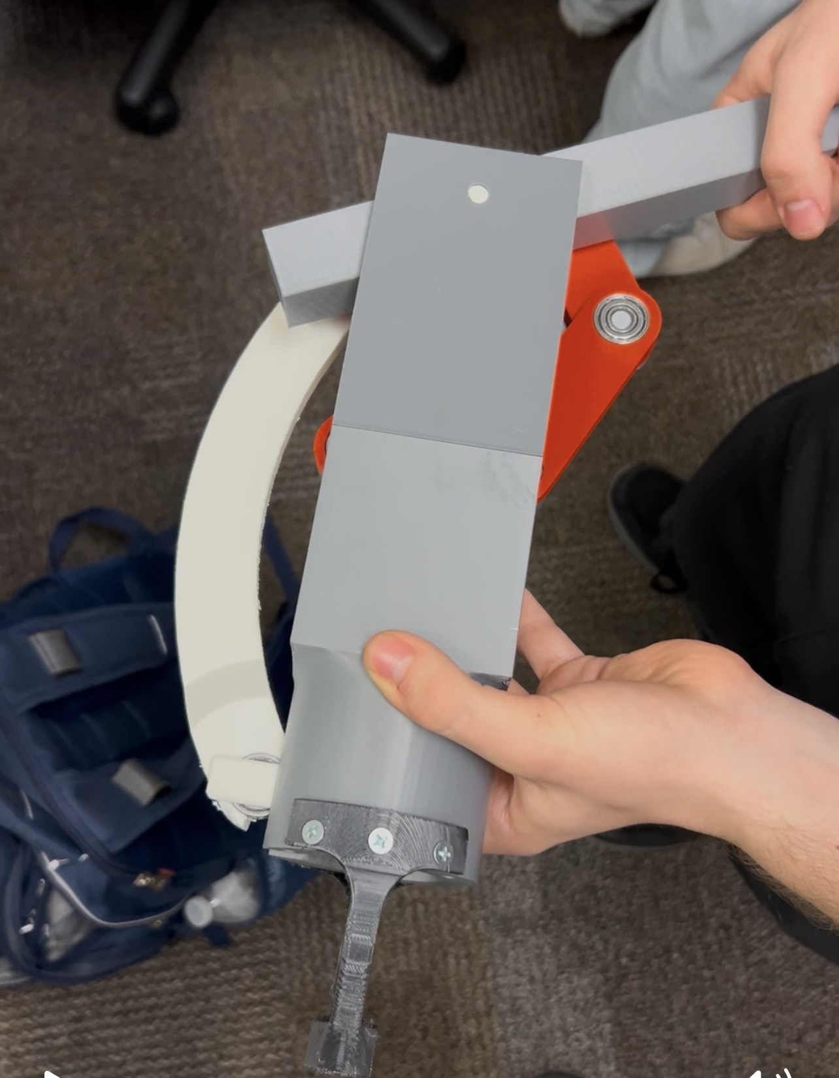
Figure 7: Start Position
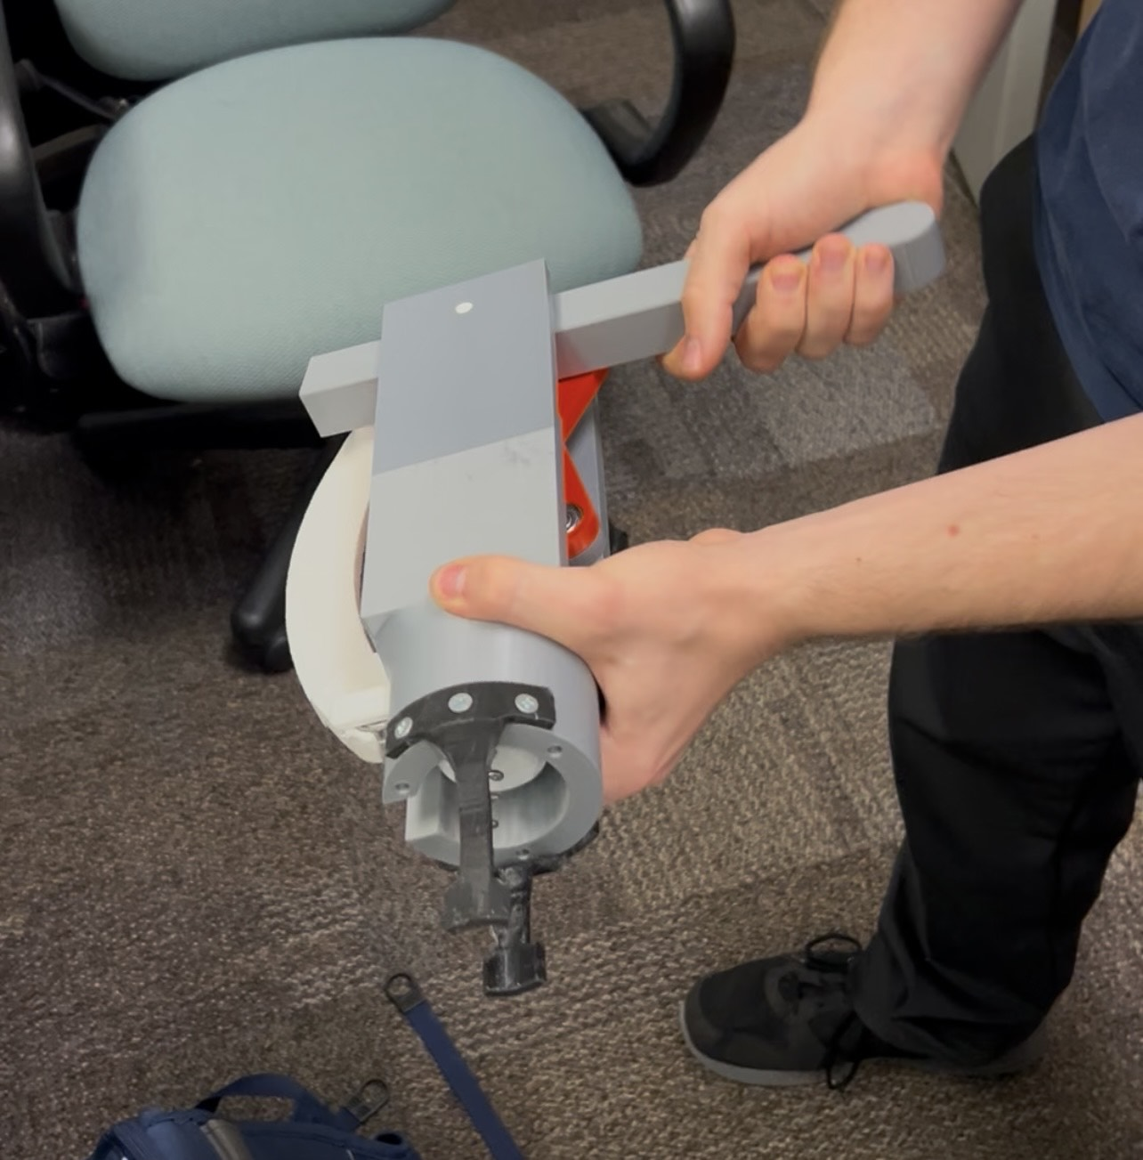
Figure 8: Intermediate Position
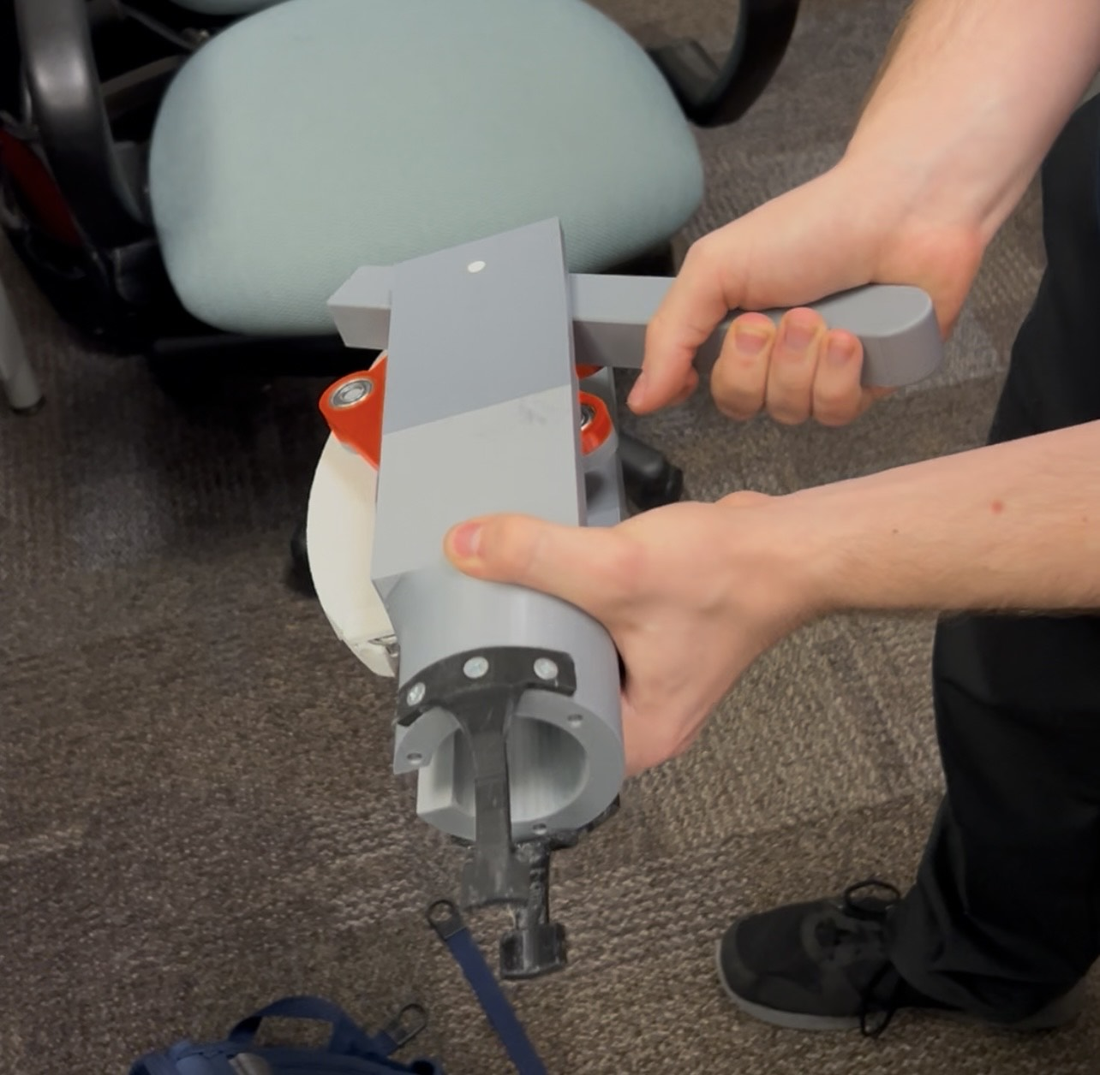
Figure 9: Final Position
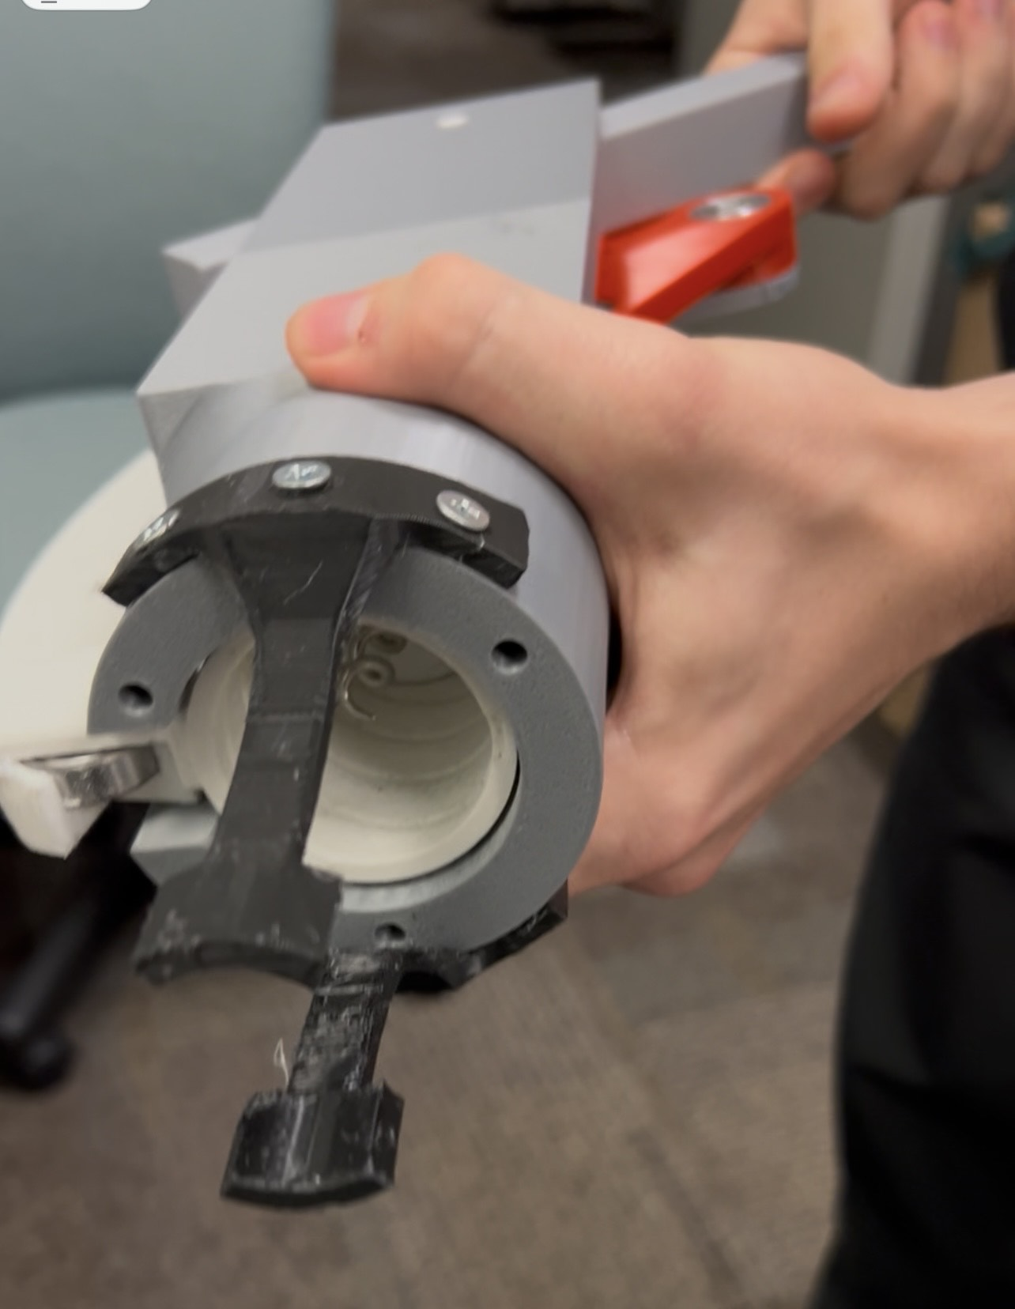
Figure 10: Start Position (Bottom View)
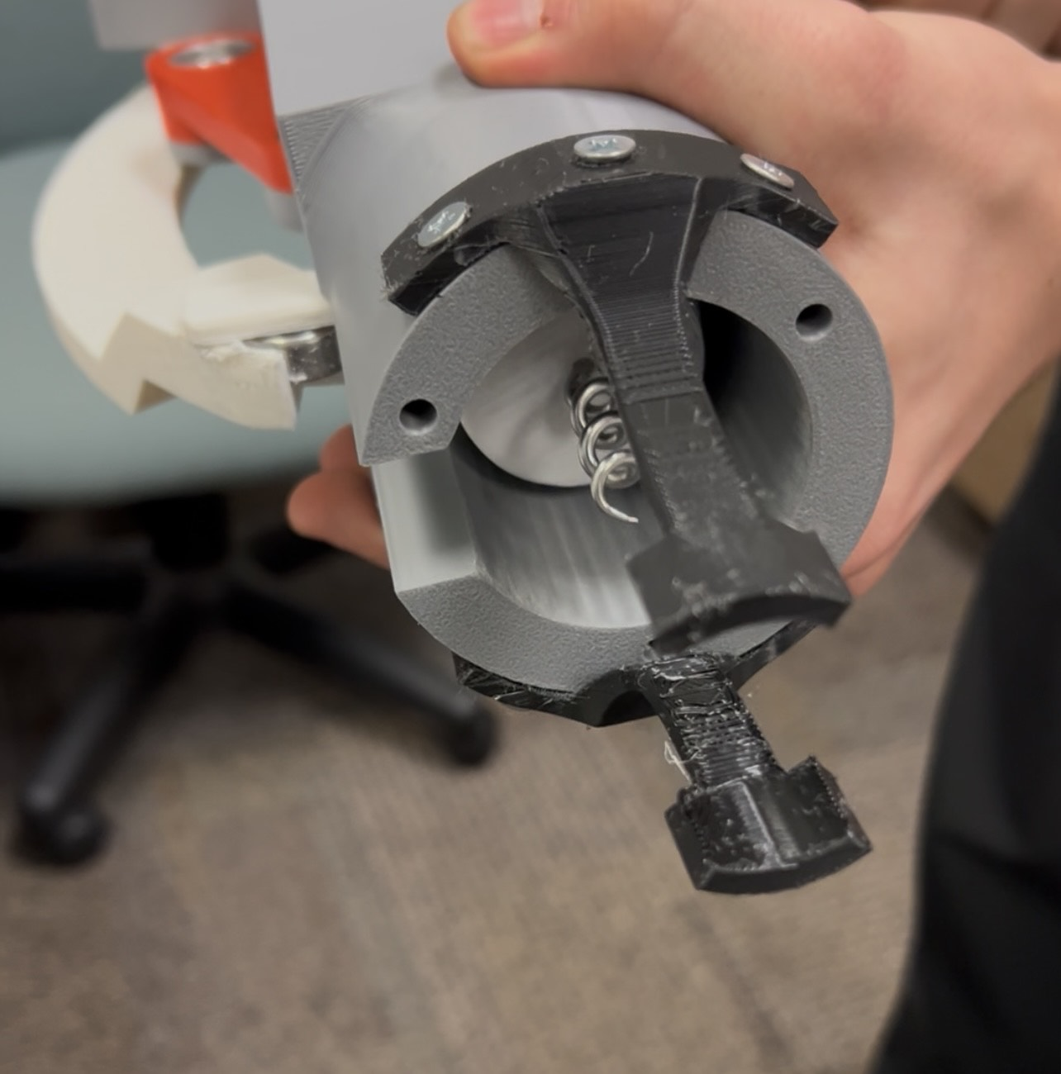
Figure 11: Intermediate Position (Bottom View)

The mechanism worked exceedingly well. When first assembled, there was significant friction resisting the threading rotation, this was corrected by using a Dremel and lubricant which solving the friction problem. Next we noticed that the upper portion of the mechanism which attached to the lever arm, link 2, had play and would wobble back and forth which made the links bind somewhat. This was an easy fix,and we printed a spacer to eliminate the room near the top allowing it to wobble. Once the spacer was inserted, that wobble was no longer an issue. When the lever arm was fully extended down link 9 the rifled cylinder would just barely exit the cylindrical portion of the housing allowing it to catch on the lip of the housing and prevent the user from returning the mechanism to the start position. To correct this a set screw was installed to limit the range of motion on the down stroke so that it did not exceed that mark. This solved that issue. After correcting all of these issues the mechanism worked exactly as designed with no movement issues and therefore was a successful prototype showing that the design is functional and working.
After confirming the movement and range of the mechanism was to spec and without issue, we were able to test the device on an actual cork. The corkscrew penetrated the cork, but it became apparent halfway through that the plastic the mechanism was printed with did not have the strength to complete the uncorking. As we did not want to break the mechanism we stopped. This was expected as we were using a lightweight PLA and not all the pieces were printed with 100% infill. For the mechanism to be fully tested, we would need to reprint with a stronger composite material. We do not have the resources or the printer available to print in more suitable material and therefore are not able to complete this.
The primary changes we would make to the prototype would be changing the material in which it was made. This would allow us to increase the durability of the mechanism and shrink the size of each member to make a more compact mechanism. Additionally, for mass production or sale the housing would be designed to hide the moving links. We intentionally left the housing open so that the movement of the mechanism could be shown.

